Using *tcpdump* to trace Relayer packets

# CSCI 4760

**What is this?** These notes provide additional information on using the new relayers on VM60 to solve your ReliableTransport assignment.

## Reconfigure your application

Here are the new IP addresses and port numbers. Only the IP address has changed! As before, I suggest you start with the reliable relayer, move to the semi-reliable relayer, and then graduate to the unreliable relayer:

|  |  |  |
| --- | --- | --- |
| Relayer | IP | UDP Port |
| Reliable | 172.17.152.60 | 2019 |
| Semi-reliable | 172.17.152.60 | 2020 |
| Unreliable | 172.17.152.60 | 2021 |

## Using tcpdump

You will need three terminal windows (or cleverly run background processes redirecting their output to files that you can read later):

1. In one window, start your receiver.
2. In another window, start tcpdump: **sudo tcpdump –c 100 udp .** The –c flag stops tcpdump after 100 packets have been captured. You can also stop tcpdump with the Ctrl-C key combination.
3. Finally, start your sender. If it blows up without sending any packets, you must stop tcpdump and fix the errors before retrying.

## Reading the tcpdump output:

Before you get your sender started, you will see the normal UDP “chatter” on your system, primarily DNS and NetBios:

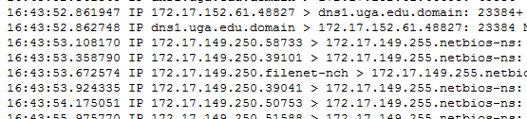

Towards the end, the traffic will be dominated by your packets. The following dump trace was captured running the app from vm60:

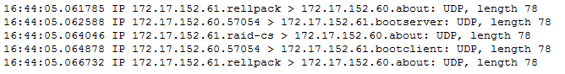

Tcpdump uses the “well-known” UDP service port numbers, which makes it more difficult to interpret the port numbers in the result. Looking these up in a resource such as <http://www.iana.org/assignments/service-names-port-numbers/service-names-port-numbers.xhtml> you will find:

* Rellpack = UDP port 2018
* About = UDP port 2019
* Bootserver = UDP/TCP port 2016
* Raid-CS = UDP port 2015
* Bootclient = UDP port 2017

The dialog above can now be interpreted:

1. VM 61 sends a packet from port 2018, to the reliable relayer port 2019 on VM 60;
2. VM 60 sends a packet to our ack receive port, 2016.
3. VM 61 sends a packet from port 2015 to the reliable relayer port 2019 on VM 60;

-and so forth. Why is VM61 sending from two different ports? Port 2015 is DATA_SEND_PORT used by the sender, while 2018 is ACK_SEND_PORT used by the receiver. Way cool, eh?

## Using the Relayer Log

Once you have confirmed that your packets are being sent to the relay host, use the relayer log app at <http://172.17.152.60:8080/RelayerLog/> to see what the relayer did with your packets. Have fun!